**Motivation/Importance**

Detecting waterbodies from satellite images using object-based techniques is crucial for various applications. It aids environmental monitoring by tracking aquatic ecosystems and supporting conservation. Water resource management benefits from precise mapping of rivers and lakes, while disaster management relies on accurate waterbody detection for flood prediction and response. Urban planning and infrastructure development use this data to make informed decisions, minimizing environmental impact. Agriculture benefits from real-time water resource data for irrigation planning, and climate change monitoring relies on tracking waterbody changes over time. This automated approach is cost-effective and efficient, allowing quick analysis of large geographical areas.

**Problem Statement**

Traditional methods for detecting waterbodies are slow and prone to errors, hindering environmental monitoring, disaster response, and urban planning. Automated object-based detection in satellite images offers a faster, more efficient alternative, but it faces challenges in accuracy, varied geographic contexts, and distinguishing water from similar features.

A reliable object-based approach for waterbody detection is needed. It must be adaptable to different environments, accurate in diverse conditions, and capable of processing large-scale data efficiently. Addressing these issues is essential for effective water resource management, disaster risk mitigation, and sustainable urban development.

**Model Architectures**

<https://arxiv.org/pdf/1805.09512>

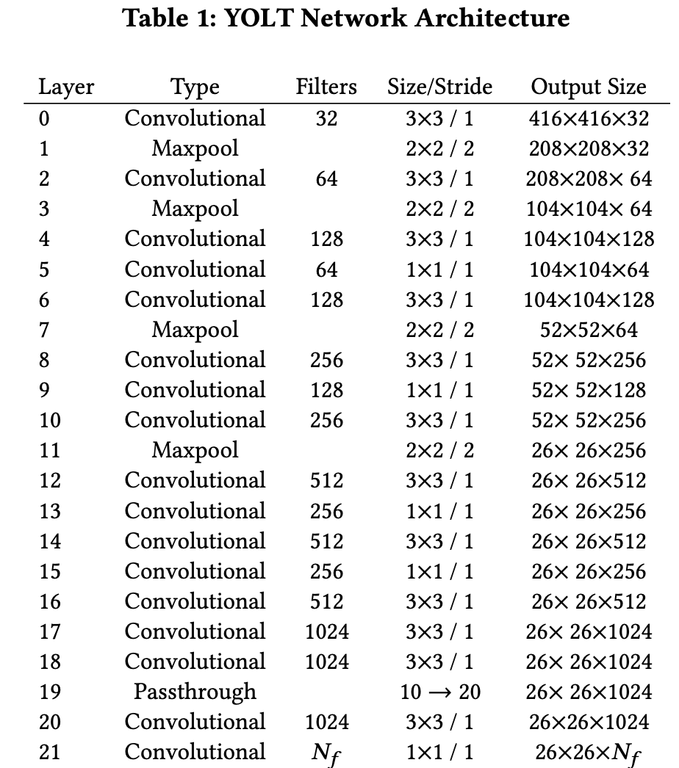

<https://openaccess.thecvf.com/content_CVPRW_2019/papers/EarthVision/Shermeyer_The_Effects_of_Super-Resolution_on_Object_Detection_Performance_in_Satellite_CVPRW_2019_paper.pdf>

ALSO USES YOLT

<https://www.mdpi.com/2072-4292/10/1/131>

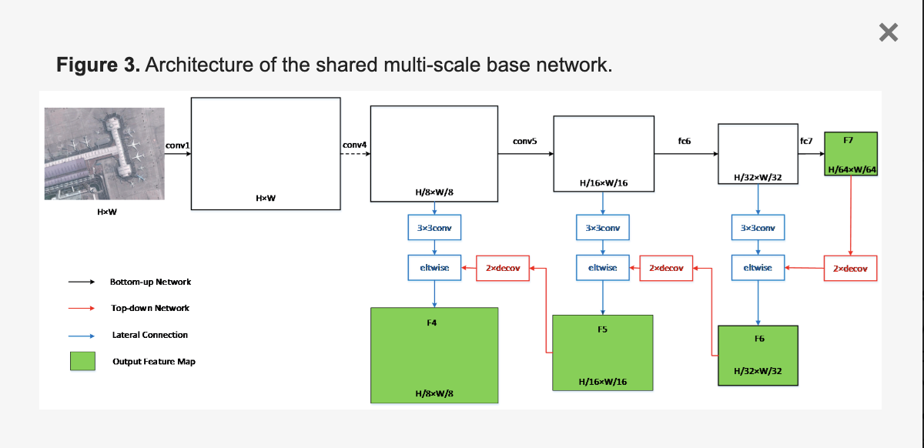

<https://www.mdpi.com/1424-8220/23/13/5849>

|  |  |  |
| --- | --- | --- |
| **Layer** | **Output Shape** | **Number of Parameters** |
| Conv2d | (3, 608, 608) | 1,792 |
| BatchNorm2d | (64, 608, 608) | 128 |
| LeakyReLU | (64, 608, 608) | 0 |
| MaxPool2d | (64, 304, 304) | 0 |
| Conv2d | (128, 304, 304) | 73,856 |
| BatchNorm2d | (128, 304, 304) | 256 |
| LeakyReLU | (128, 304, 304) | 0 |
| MaxPool2d | (128, 152, 152) | 0 |
| ... | ... | ... |
| Conv2d | (1024, 76, 76) | 2,359,296 |
| BatchNorm2d | (1024, 76, 76) | 2,048 |
| LeakyReLU | (1024, 76, 76) | 0 |
| Conv2d | (255, 76, 76) | 261,375 |

<https://www.sciencedirect.com/science/article/pii/S2666592122000531>

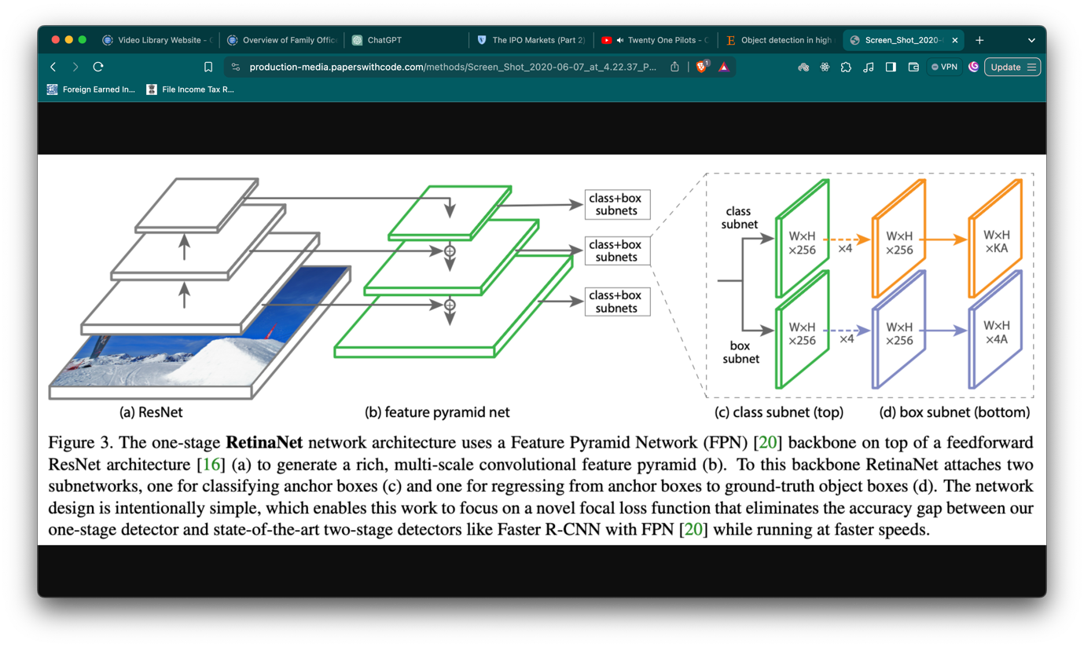

<https://www.mdpi.com/2072-4292/15/12/3009>

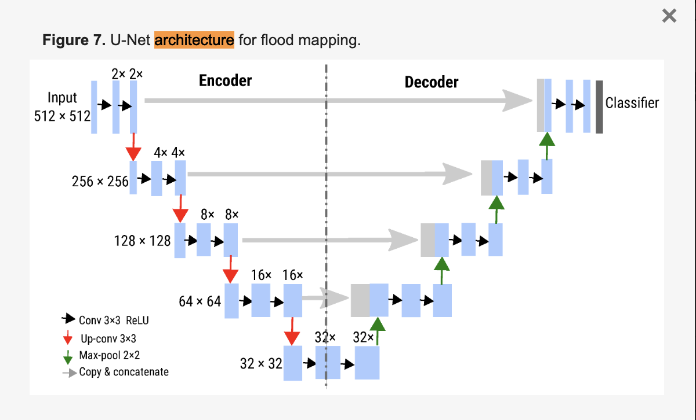

<https://www.mdpi.com/2073-4441/14/7/1148>

ALSO USES U-NET

<https://www.sciencedirect.com/science/article/pii/S2667305323000479>

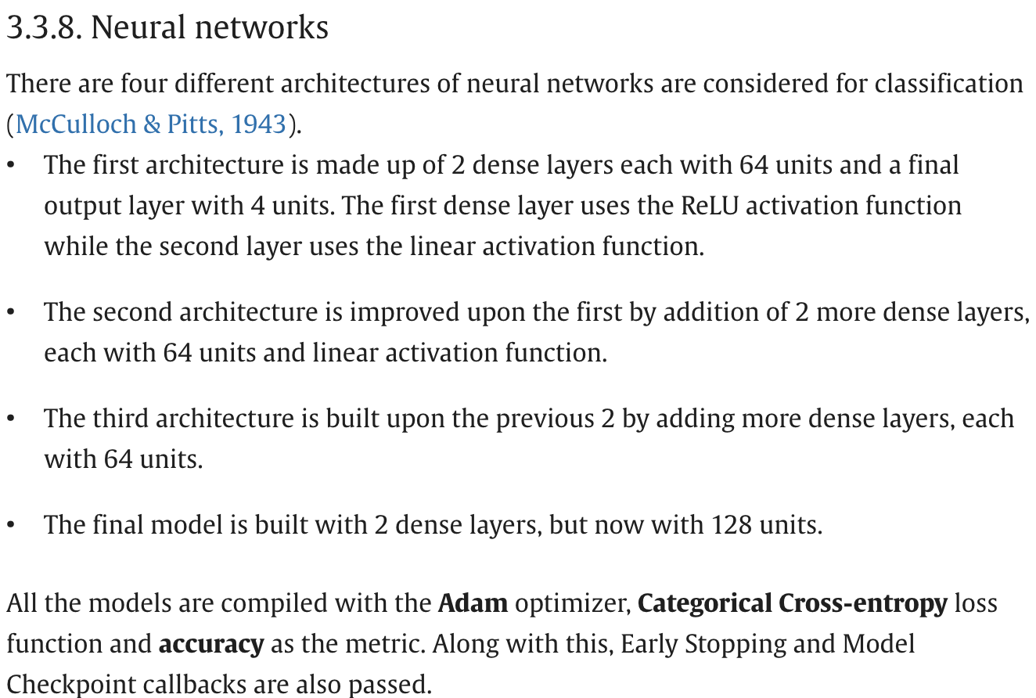

<https://ieeexplore.ieee.org/stamp/stamp.jsp?arnumber=9492784>

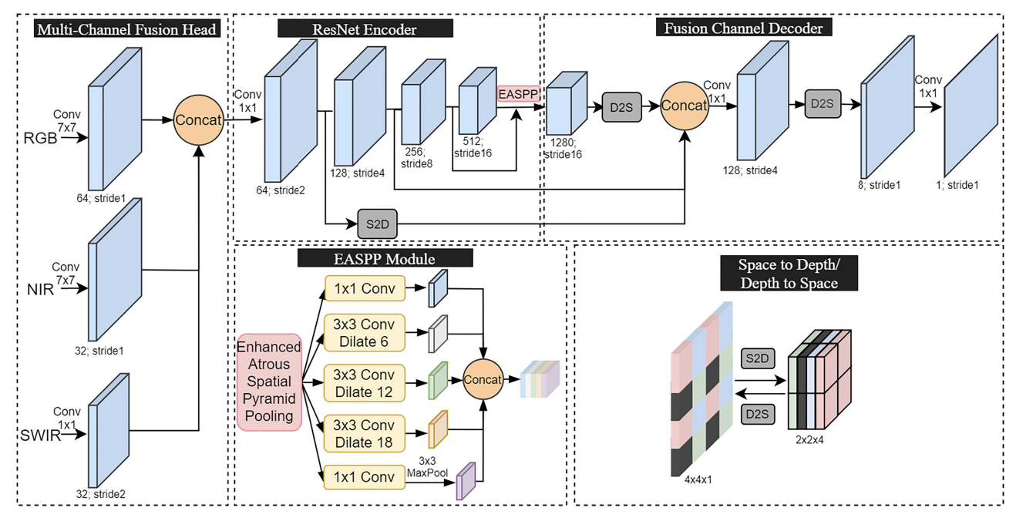

<https://www.cscjournals.org/manuscript/Journals/IJIP/Volume3/Issue6/IJIP-106.pdf>